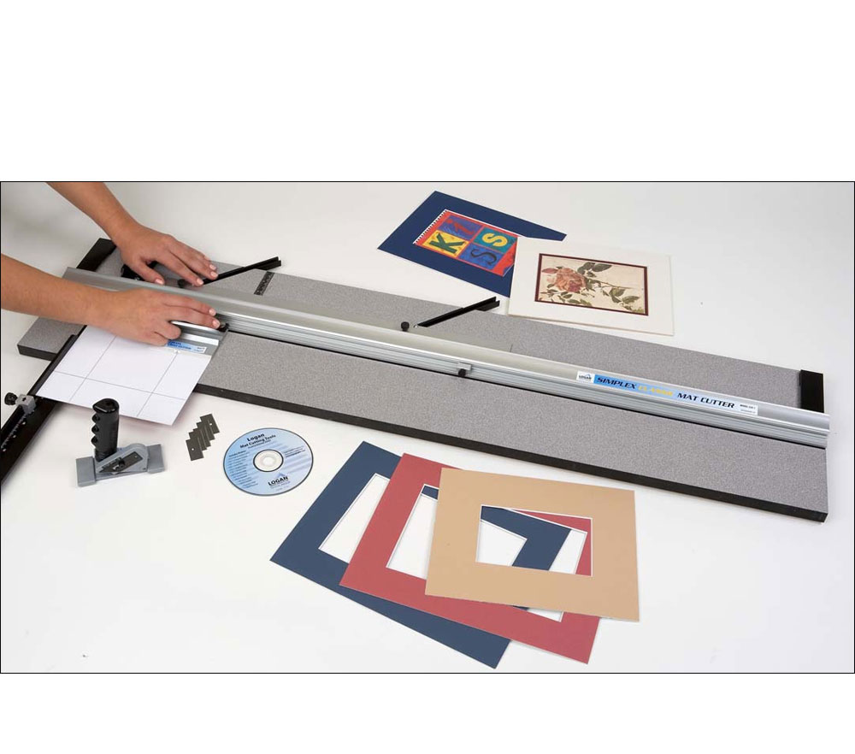
Beginning
Mat Cutting Workshop

Bring out the best in artwork!
Cost $35.00 per session

Spokane Art Supply
N 1303 Monroe 509.327.6622
To register Call Shirley at 509 981 6811
we will set a time and date that is a convenient for you

In the Mat Cutting Workshop learn the ins and outs of mat cutting
with step-by-step instructions and demonstrations and you will take home two mats you have cut yourself.
Learn basics, about mat board and supplies ……. how to choose the best color combination and type of matting … suggestions for choosing an appropriate mat that both looks great and safely displays your piece…. as well as how to take accurate measurements
You will learn how to cut a Basic Single Beveled Mat.
You will learn how easy it is to make double mats.

You will learn how to achieve quality mat cutting results by overcoming
common problems like over cuts and under cuts.

You will learn a little known but critical fact about mat board.

You will learn that you do not need expensive equipment to
cut your own mats right in your own home.

You will receive hands-on instruction.
Mat cutters, equipment, materials and pre-cut small mat boards are provided for workshop use

